(Approx. 385 words)

Review: SanDisk Ultra Dual USB Drive - Android file transfers made easy
By Frank Ramsey, Editor, Akron Canton PC Users Group (ACPCUG), Ohio
www.acpcug.org
Aframsey (at) yahoo.com

Your first question is probably what is a dual USB drive and why might it be useful?

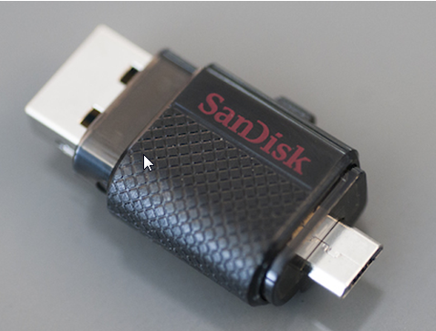
In this context, a dual USB drive is a device that has two USB connectors. In the case of the SanDisk Ultra, as shown in the picture, it has a standard USB type A male and a standard micro USB male connector.
The connections are not to be used at the same time.

There are covers that slide over the connectors, protecting them. Since the covers are attached to the device itself, you cannot lose the cover. Best Buy has them in sizes of 16GB, 32GB and 64GB, priced around $15, $25 and $50 respectively.

Yes, you could use an OTG (on the go) cable and a standard USB device with a USB type A male connector. I personally guarantee that no matter how many OTG cables you have, there will a time when you need it that you cannot find it. Not the case with this device. The two connectors are always attached to the device.

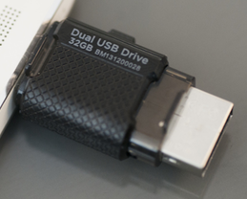
To use, slide the cover back on the connector to use and plug in the device.

Android and PC devices will typically recognize the device as external storage.

When is the device useful? When you want to backup stuff on an Android device, or transferring large amounts to/from the Android device.

Think of the picture library on your Smartphone. Have you protected it? What would happen if you drop the phone into the sink? Are your pictures gone?

Not if you use this device. Plug it into the smart phone. Using your favorite file manager, select the picture library (typically contained in a folder called DCIM). Click copy. From within the file manager, browse to the SanDIsk dual USB device, typically called USBDriveA (or B or C). Select the device. Click, paste and wait untill the picture library has been copied.

Now, unplug the SanDisk dual USB device from your Smartphone and plug it into your PC, copying the picture library to your PC, the Cloud, or an external USB device attached to your PC. The possibilities are endless.

Great device. Highly recommended.

